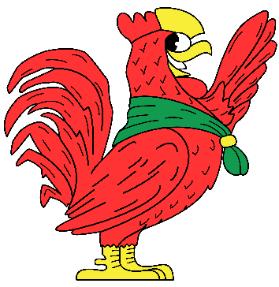
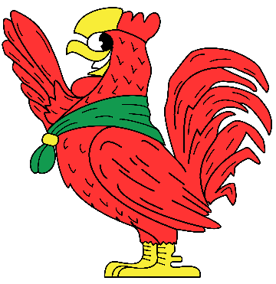

2019 PROGRAM HIGHLIGHT SHEET
WEEKLY THEMES

Week 1: Wild West Week  Yee-haw! Welcooome to the Wild West Bow. Grab your cowboy hats and put on your spurs, because it's time to head out into the frontier! Join us for the exciting first week as we celebrate the 90th anniversary of the Rathom Lodge. | Week 2: Spy Week  I Spy a mission at camp and it looks like we could use your help. Your mission, should you choose to accept it: take on all the adventures Yawgoog has to offer!
Week 3: Halloween Week  Look under your tent and watch out for things that go bump in the night? Whatever you do, don’t look under the bed! Beware of ghosts, werewolves, mummies and more! When things get spooky do you know who you’re gonna call? | Week 4: Superhero Week  Is it a bird? Is it a plane? No, it’s your favorite superheroes to save the day! Dust off your capes and don your masks because Elmo the Elk will need all the heroes he can get to stop the evil band of villains who have taken over Medicine Bow!
Week 5: Music Week  Break out your drum sets and guitars, because it’s time for some rock and roll! Get your band (or Troop, whichever one you prefer) together for an awesome week that is sure to hit all the right notes. | Week 6: Travel Through Time Week  Yawgoog has been sent back in time come join us as we navigate through the history as we try to return home. Who knows what decade camp will end up in next?!
Week 7: FairyTale Week  Grab your swords and pointy hats and head on down to camp Medicine Bow! Is your troop ready for a mighty quest that will put the fellowship to shame? Gather your roundtable for this exciting quest of scouting adventure. | Week 8: Jurassic Week  Medicine Bow is crawling with raptors, cavemen, and T-Rexes, oh my! There may even be a megalodon swimming in the pond. Get ready for a week in the stone age filled with fun, friends, and fossils!

Elmo’s Troop of the Week
The Troop with the greatest participation, accomplishment, and Scout Spirit will earn the Bow’s greatest honor, Elmo’s Troop of the Week! Earning medallions from the activities may help you earn this honor, but it is not the only thing Elmo looks for! Representing the Scout Law, Oath, Motto, Slogan, and having a positive attitude plays a key role in Elmo’s judgement

Fred’s Troop of the Week
The Troop that displays the most Scout Spirit will earn this equally great honor, Fred’s Troop of the Week! Earning medallions from the activities may help you earn this honor, but it is not the only thing Fred looks for! Representing the Scout Law, Oath, Motto, Slogan, and having a positive attitude plays a key role in Fred’s judgement!

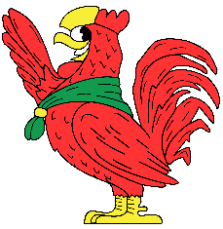
Medicine Bow Troop Activities

Troop Tournament & Scoutmaster Tournament
Get ready to go head-to-head with other troops each day after lunch in a certain sporting activity or scoutcraft skills competition. Events could include ultimate frisbee, volleyball, pioneering competitions, and many others! Scoutmasters will be competing each day after lunch in Horseshoes or Cornhole!
Monday Night Campfire (Monday)
Join the Medicine Bow staff at 8pm in the Medicine Bow Amphitheatre as we kick off the week with a great campfire accompanied by some skits and songs!
Silver CY Cracker Barrel (Tuesday)
This event will occur in the Medicine Bow Dining Hall at 8:30pm. It is required for Silver CY Candidates, Senior Patrol Leaders, and open for any senior boy leaders in the troop who may want to attend. The Program Commissioners will be providing a variety of skills and knowledge to develop their leadership capability!
Bake-Off (Wednesday)
The Bake-Off is a tasty and creative way for troops to get involved! Each Troop will bring their own ingredients and submit a baked dessert or food item to the stage of the Dining Hall by 5:30pm. The judging of the Bake-Off will take place directly following dinner. Entries will be judged based upon taste, level of difficulty, and relation to the theme! The item must be baked! (Dutch ovens available if requested)
Canoe Race (Wednesday)
A race against the rest of Camp Yawgoog! Send two troop representatives to take a canoe from the Medicine Bow Waterfront and paddle to Ashaway Aquatics Center, directly following dinner. The race starts at 7:15pm! Show that you have what it takes to be the best paddlers in camp!
Snacks with the Staff (Wednesday)
Ever wonder what it’s like to work at camp? Come on down to the staff lounge at 8:30pm to hang out and grab some snacks with the Medicine Bow Staff! Get the chance to ask them questions, share some stories, or learn more about us and our experience! We have staff from all over the country that could share a thing or two!
Campsite Decoration Contest (Thursday)
Troops should use creativity and scouting skills to decorate their campsite to match the week’s theme! Decorative gateways and fun props are always a great way to show off your scout spirit! The Program Commissioners will be judging each campsite directly following dinner!
Indian Lore Campfire (Thursday)
Come join the Crafts Center staff in a Native American themes campfire at 8:15pm. There will be performances such as dances and folk tales!
Scavenger Hunt (Friday)
The Scavenger Hunt is a fun and fast-paced scramble to acquire all of the items on a list. The list will be given to two representatives at the Medicine Bow dining hall at 8:15pm. The items should be returned to the dining hall by 9:00pm to be judged! Results will be announced at the following breakfast.
Sailing Regatta (Friday)
The Sailing Regatta takes place directly following dinner at the Ashaway Aquatics Center. The race begins at 7:00pm and is an exhilarating opportunity to show you are the best sailing crew in all of Yawgoog!
Swim Carnival (Saturday)
After lunch, there will be a fun-filled competition at the waterfront! There will be all types of aquatic events such as the Relay to the Tin Man! No one can forget the immense creativity we always see in the Scoutmaster Splash, too!
Saturday Night Show
As the week winds down, there is always the Saturday Night show to look forward to! After we line up on Marvel Road at 7:45pm, we will walk down to the J. Harold Williams Amphitheatre. All three camps join together to watch a great performance put on by the staff!
Dress Parade (Sunday)
After lunch, all of the troops are recognized for their weeks’ worth of hard work and accomplishment. We will all come together for one last time on the Tim O’Neil Field. Be sure everyone in your unit has full class A uniform for the parade!

